Student ID:

21C11036

Name:

Nguyen Thi Ngoc Tram

Deployment architecture

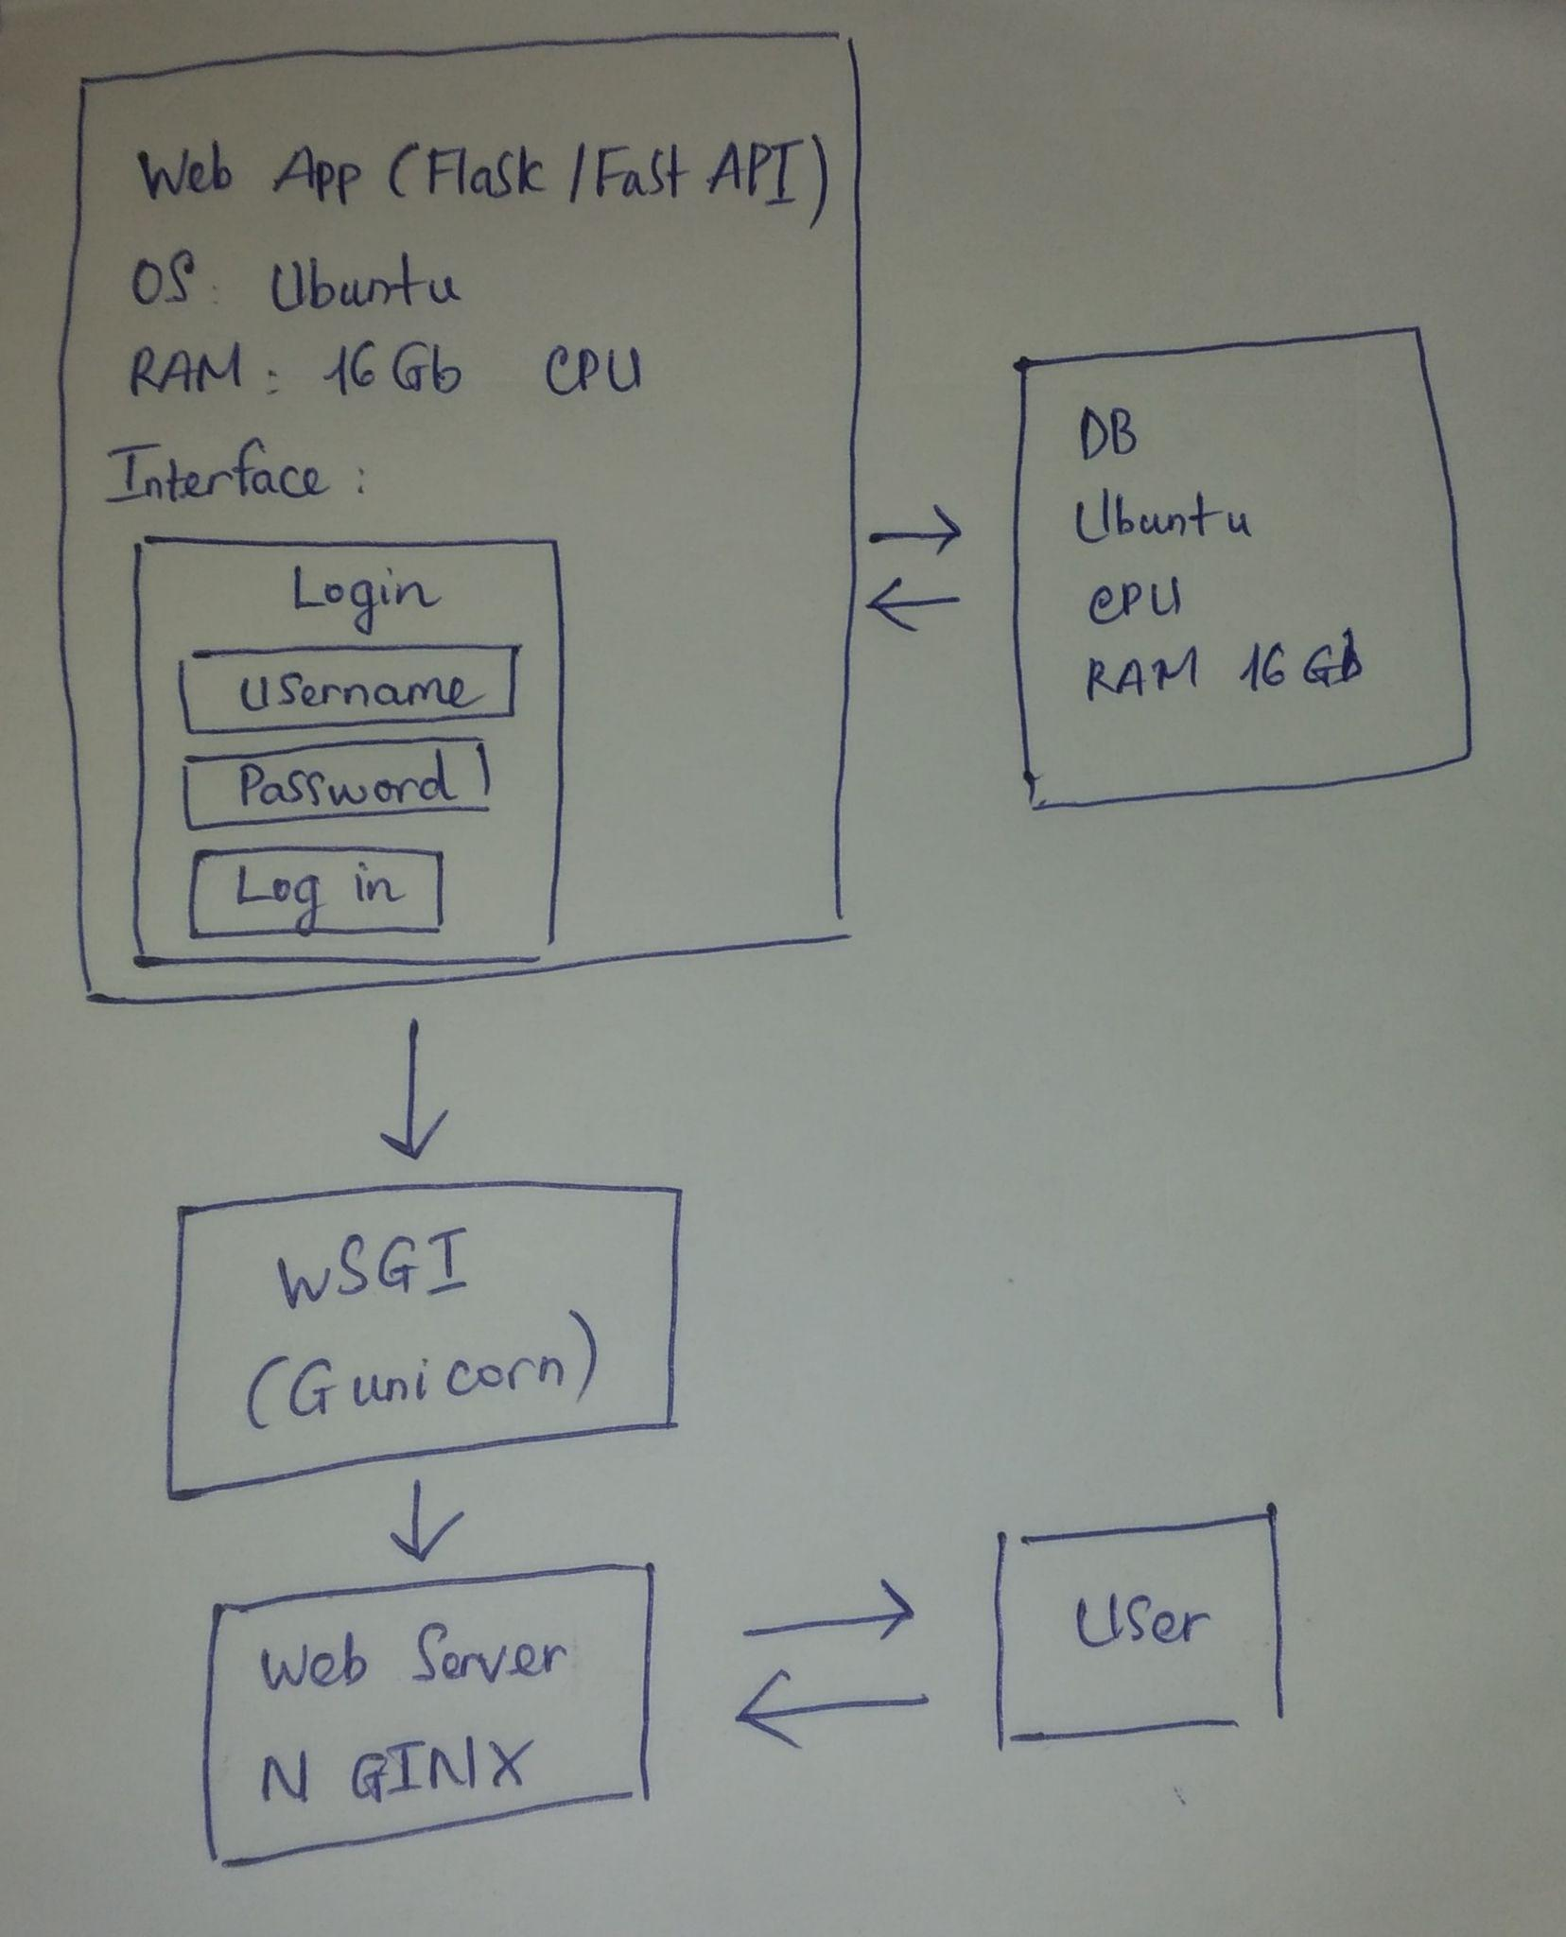

Demo video: Do chưa kịp hoàn thành nên em gửi thầy video demo những phần em đã làm được ạ. Mong thầy thông cảm.

<https://drive.google.com/file/d/1Onogbb95GKzzyUTXMHONt4jtKuBp6D3u/view?usp=sharing>

Cloud provider URL

Amazon

Deployed software URL

Deployed software admin email or username

Deployed software admin password